

NATIONAL ECONOMIC CONSULTATIVE FORUM

MONTHLY ECONOMIC BULLETIN

MARCH 2024

Executive Summary
This bulletin focuses on economic developments for the month ending 28 March 2024 that include: Zimbabwe Gross Domestic Product (GDP) growth updates, merchandise trade developments, exchange rate developments, inflation developments, monetary developments and stock market developments as well as world economic developments and international commodity prices.
The global economic growth is projected to remain constant at 3.1% in 2024 before taking a steady increase in 2025 to 3.2%, according to the International Monetary Fund (IMF) World Economic Outlook, January 2024. The global economy is expected to stabilize due to stronger-than-expected resilience in the United States and several large emerging markets and developing economies, as well as fiscal support in China and global recovery from COVID-19. On the other hand, global inflation is expected to gradually fall from 6.9% in 2023 to 5.8% in 2024 and further to 4.6% in 2025.
Month-on-Month (MoM) international commodity prices of the selected commodities registered an upward trend except for natural gas, nickel, cotton and wheat owing to the ongoing Gaza and Ukraine wars which disrupted supply chains, economic reopening as well as industrial revival from effects of COVID-19 which increased demand.
In Zimbabwe, the economy is projected to take a U-shaped growth, as it is expected to have a sharp economic slowdown in 2024 from a growth of 5.5% in 2023 to 3.5% in 2024 and a recovery to 5% 2025, according to the Ministry of Finance, Economic Development and Investment Promotion (MoFEDIP). Meanwhile, the IMF projected growth to fall from 4.1% in 2023 to 3.6% in 2024 and marginally decline to 3.5% in 2025. Projections by MoFEDIP are informed by the effects of El Nino induced drought, power supply shortages, high inflationary pressures, exchange rate volatility, high interest rates and uncertain global economic outlook emanating from geopolitical developments.
The local currency (ZWL$) depreciated against all major currencies during the period under review. Transactions in the economy continued to be characterized by a dual exchange rate system whereby the interbank rate and the parallel market rate. The gap between the two exchange rates continued to widen leading to an increased parallel market premium. As at 28 March 2024, the official exchange rate was at USD1: ZWL$22055.47 while the parallel market rate was at around USD1: ZWL$40000 translating to a premium of 81.36%. Meanwhile, on Year on Year, the United States dollar depreciated against the British Pound and while gaining against the Euro and the South African Rand.
Regarding inflation, the month-on-month inflation for March 2024 was at 133.39% from 127.17% in February 2024. The main drivers being food, non-alcoholic beverages, housing, water, electricity, gas and other fuels.
Meanwhile, during the reporting period data on broad money supply (M3) had not been published by the Reserve Bank of Zimbabwe. Thus, analysis relied on data available as at January 2024. In this regard, M3 reached ZW$18.87 trillion at the end of December 2023, up from ZW$14.27 trillion in June 2023. In January 2024, M3 stock totalled ZW$29.25 trillion. The expansion of ZW$3.18 trillion in transferable deposits accounted for the majority of the rise.
Similarly, by the time of compiling the report, the Zimbabwe National Statistical Agency (ZimStat) had not published data on merchandise trade, therefore, the analysis was mainly based on 2023 data. The current account surplus is projected to shrink to around US$125.6 million in 2023, down from a surplus of US$305.0 million in 2022. This followed a widening of the merchandise trade imbalance, which was mostly driven by relative import increases in the face of declining exports as most global commodity prices fell.
Regarding stock market developments, the Zimbabwe Stock Exchange recorded a bullish trend with an All-Share Index growth of 66.25% on MoM while the Victoria Falls Stock Exchange was characterized by positive trading with a gain of 2.52% on MoM.
Contents
Executive Summary i
1.0 World Economic Developments 1
1.1 World Output 1
1.2 Global Inflation Developments 2
2.0 International Commodity Prices 2
3.0 Zimbabwe GDP Growth Update 3
4.0 Merchandise Trade Developments 4
5.0 Exchange Rate Developments 5
5.1 Zimbabwean Dollar Exchange Rate Developments 5
5.2 Cross Rate Developments 6
6.0 Inflation Developments 6
7.0 Monetary Developments 7
7.1 Money Supply 7
7.2 Interest Rates 8
8.0 Stock Market Developments 8
8.1 Zimbabwe Stock Exchange 8
8.2 Victoria Falls Stock Exchange 8
9.0 Recommendations 9
10.0 References 10

List of Figures
Figure 1: Global Inflation Prospects 2
Figure 2: Zimbabwe Economic Growth Prospects 3
Figure 3: Merchandise Trade Developments 4
Figure 4: Exchange Rate Developments 5
Figure 6: Month-on-Month Inflation Outturn 6
Figure 7: Broad Money Stock Movements 7

List of Tables
Table 1: Global Economic Growth Developments 1
Table 2: Commodity Price Movements – Month Ending 28 March 2024 3
Table 3: ZWL$ Exchange Rate Movements – Month Ending 28 March 2024 5
Table 4: USD Exchange Rate Movements – Month Ended 28 March 2024 6
Table 5: Inflation by Sector March 2024 7
Table 6: Zimbabwe Stock Exchange Movements 8
Table 7: Victoria Falls Stock Exchange Movements 9

1.0 World Economic Developments

1.1 World Output
1.1.1 According to the International Monetary Fund's (IMF) World Economic Outlook Update for January 2024, the global economic outlook is expected to stabilise due to stronger-than-expected resilience in the United States and several large emerging market and developing economies, as well as fiscal support in China and global recovery from COVID-19.
1.1.2 As shown in Table 1, global economy is expected to maintain a growth of 3.1% from 2023 to 2024. In terms of outlook, world output is expected to slightly pick up to 3.2% in 2025.
1.1.3 Table 1 summarizes global economic growth developments and prospects for selected regions and countries.
Table 1: Global Economic Growth Developments
 | 2023 | 2024 | 2025
World Output | 3.1 | 3.1 | 3.2
Advanced Economies | 1.6 | 1.5 | 1.8
United States | 2.5 | 2.1 | 1.7
Euro-Area | 0.5 | 0.9 | 1.7
Emerging Markets & Developing Economies | 4.1 | 4.1 | 4.2
China | 5.2 | 4.6 | 4.1
India | 6.7 | 6.5 | 6.5
Sub-Saharan Africa | 3.3 | 3.8 | 4.1
Nigeria | 2.8 | 3.0 | 3.1
South Africa | 0.6 | 1.0 | 1.3
Source: IMF World Economic Outlook Update (January 2024)
1.1.4 Growth in Advanced Economies is likely to decline to 1.5% in 2024 from 1.6% in 2023 and rebound slightly to 1.8% in 2025 owing to both contractions in the United States and improvements in the European economies. Growth in the Euro-Area is anticipated to increase to 0.9% in 2024 from 0.5% in 2023 before further increasing to 1.7% in 2025 while the United States economy is expected to fall to 2.1% in 2024 from 2.5% in 2023 then to 1.7% in 2025.
The world economic movements shaping Zimbabwe economic prospects include; slow recovery of commodity prices; Ukraine and Gaza wars; and accommodative monetary policies.

1.1.5 Emerging Markets and Developing Economies are expected to maintain a growth of 4.1% of 2023 until 2024 before picking up to 4.2% in 2025. However, in terms of outlook, China’s growth is expected to slow down to 4.6% in 2024 from 5.2% in 2023 and future decline to 4.1 in 2025. India’s growth is projected to slightly fall from 6.7% in 2023 to 6.5% in 2024 and 2025.
1.1.6 Growth in the Sub-Saharan Africa (SSA) is expected to increase from 3.3% in 2023, to 3.8% and 4.1% in 2024 and 2025, respectively. In Nigeria, growth is expected to continue increasing from 2.8 in 2023 to 3% in 2024 and 3.1% in 2025. South Africa’s economic growth is expected to gradually rise to 1% in 2024 from 0.6% in 2023 and to 1.3% in 2025.

1.2 Global Inflation Developments
1.2.1 Global inflation is expected to slow down to 5.8% in 2024 from 6.9% in 2023 and further decline to 4.6% in 2025, according to the IMF World Economic Outlook Update for January 2024, as shown in Figure 1.
Figure 1: Global Inflation Prospects
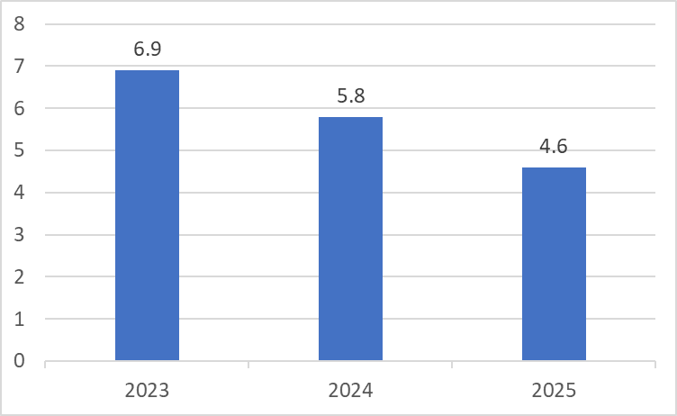
The global inflation prospects suggest towards supportive monetary policies in the international market through favorable interest rates for capital.
Source: IMF World Economic Outlook Update (January 2024)

2.0 International Commodity Prices
2.1 During the month under review, the commodity prices registered an upward trend. This was largely due to the ongoing Russia-Ukraine war which disrupted supply chains and economic reopening and strong revival in industry (recovery from COVID-19).
2.2 On a year-to-date basis (YtD), gold gained 9.58% and 13.44% on year on year (YoY) basis while copper gained 2.50% YtD and lost 2.06% on YoY. Nickel gained 3.47% and lost 29.95% YtD and YoY, respectively while Aluminium gained 2.50% on YtD and lost 3.15% on YoY. This trend especially for gold is encouraging and is a boon for the country’s mining sector as well as growth prospects.
2.3 On agricultural commodities, cotton gained 7.29% and 10.39% on YtD and YoY, respectively, whilst wheat lost 7.43% on YtD and 19.07% YoY. Corn lost by 3.60% YtD and 33.08% YoY. Cotton, corn, and wheat prices prospects are discouraging for the country’s agricultural sector growth prospects.
2.4 On a monthly basis, crude oil (brent), aluminum, copper, gold, soyabeans and corn recorded gains while the rest of the commodities recorded losses as Shown in Table 2. The increase in the price of Brent has an adverse effect on the economy as it results in the increased fuel prices and increases the cost of production leading to depressed aggregate demand and reduced economic growth.
Table 2: Commodity Price Movements – Month Ending 28 March 2024
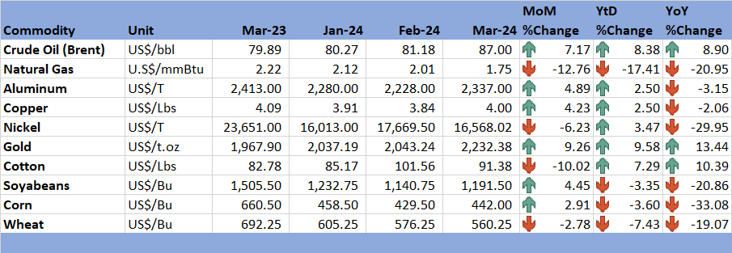
Source: Trading Economics (2024)

3.0 Zimbabwe GDP Growth Update
3.1 According to the 2024 National Budget Statement, Zimbabwe's GDP is anticipated to increase by 3.5% in 2024, lower than the IMF's projection of 3.6% as shown in Figure 2.
Figure 2: Zimbabwe Economic Growth Prospects
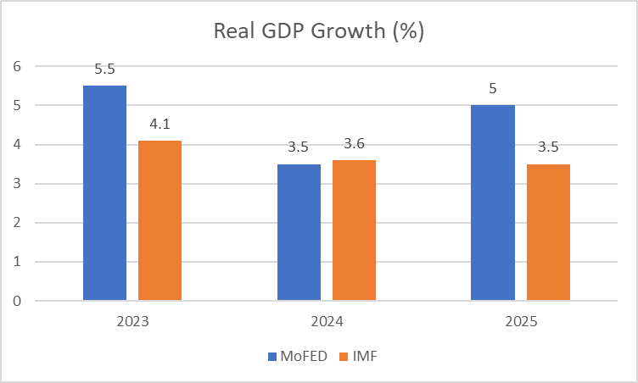
Source: MoFEDIP (2023); IMF World Economic Outlook Update (January 2024)
3.2 The growth rate in 2024 is expected to be lower than in 2023 due to the effects of the El Nino induced drought. The El-Nino-induced drought turned out to be more severe than initially anticipated and is expected to impact negatively on the domestic economy’s growth trajectory. The dry spell and high temperatures experienced since the beginning of February 2024 have greatly affected the 2023/24 summer crop which was generally fair in January 2024. The domestic growth trajectory will also be affected by a slowdown in commodity prices, and subdued aggregate demand.
3.3 In terms of outlook, the MoFEDIP anticipates economic growth to pick up from 3.5% in 2024 to 5% in 2025, compared to a decline from 3.6% in 2024 to 3.5% in 2025 projected by the IMF. El Nino-induced drought, an unfavourable global economic outlook caused by geopolitical factors such as the Ukraine and Gaza wars, power supply shortages that will affect production, macroeconomic instability characterised by high inflation pressures and currency instability, and the aftermath of the COVID-19 pandemic are all potential risks to the outlook.

4.0 Merchandise Trade Developments
4.1 By the time of compiling the report, the ZimStat had not published the merchandise trade data, thus the analysis relied on the available data. In this regard, according to forecasts from the Reserve Bank, the current account surplus is projected to shrink to around US$125.6 million in 2023, down from a surplus of US$305.0 million in 2022. This followed a widening of the merchandise trade imbalance, which was mostly driven by relative import increases in the face of declining exports as most global commodity prices fell. The current account balance was further dragged down by the services and primary income accounts, which also posted deficits.
Figure 3: Merchandise Trade Developments
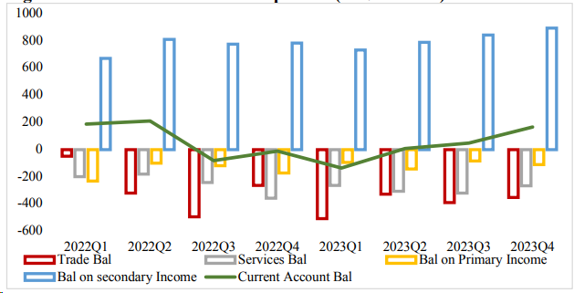
Source: RBZ (2024)
4.2 Merchandise exports are estimated to have decreased by 0.8%, from US$7.0 billion in 2022 to US$6.9 million in 2023, largely weighed down by subdued mineral exports. The decline in mineral exports was, however, partially offset by increases in agricultural and manufactured exports.
4.3 During 2023, merchandise imports are estimated to have risen by 4.9% to US$8 527.8 million, from US$8 131.8 million in 2022. Increased fuel, machinery, electricity, and grain imports drove the growth. As the economy expands, its capacity to accommodate imports that support the production process also grows.

5.0 Exchange Rate Developments

5.1 Zimbabwean Dollar Exchange Rate Developments
5.1.1 During the period under review, the Zimbabwean Dollar (ZWL$) depreciated against all major currencies, as shown by Table 3. On MoM basis, the ZWL$ depreciated by about 40.23% against the USD. On an YtD and YoY basis, the ZWL$ lost by 117.24% and 2275.16%, respectively against the USD.
Table 3: ZWL$ Exchange Rate Movements – Month Ending 28 March 2024
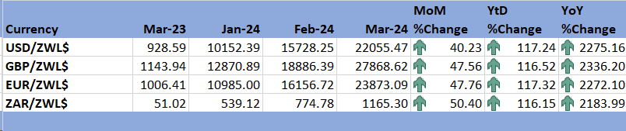
Source: RBZ (2024)
5.1.2 During the period under review, the market exchange rate premium remained high inhibiting the opportunity for convergence between the official and the parallel market exchange rates as indicated in Figure 4.
Figure 4: Exchange Rate Developments
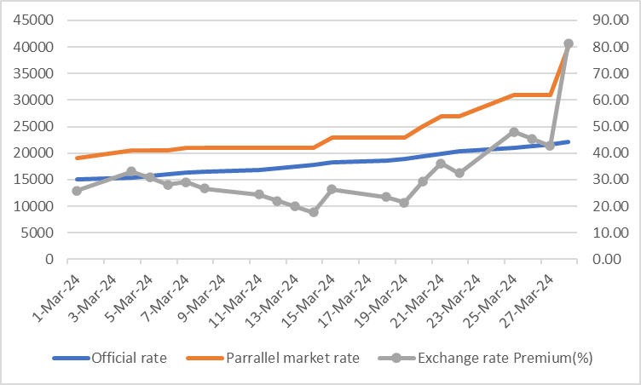
Source: RBZ (2024) and Harare Streets

5.2 Cross Rate Developments
5.2.1 On MoM basis, the USD depreciated by 1.67% against the South African Rand (ZAR) and gained against the British Pound and EUR, as shown in Table 4. If the trend of appreciation of the ZAR against the USD is maintained going forward, this has the effect of discouraging imports from South Africa and promoting local production and exports.
Table 4: USD Exchange Rate Movements – Month Ended 28 March 2024
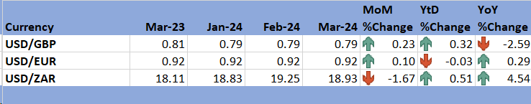
Source: RBZ (2024)
5.2.2 Meanwhile, the ZAR weakened by 0.51% on YtD basis and 4.54% on YoY basis against the USD as the economy was still recovering from the COVID-19 pandemic effects. This trend of weakening of the ZAR is discouraging as it has a negative impact on competitiveness of Zimbabwean goods in the South African market.

6.0 Inflation Developments
6.1 During the period under review, MoM inflation stood at 4.9% down from 5.4% recorded in the previous month, see Figure 6.
6.2 On the other hand, all items monthly inflation rate for March 2024 was at 133.39% up from 127.17% in February 2024 (see Table 5). The main drivers being food and non-alcoholic beverages and housing, water, electricity, gas and other fuels.
Figure 5: Month-on-Month Inflation Outturn
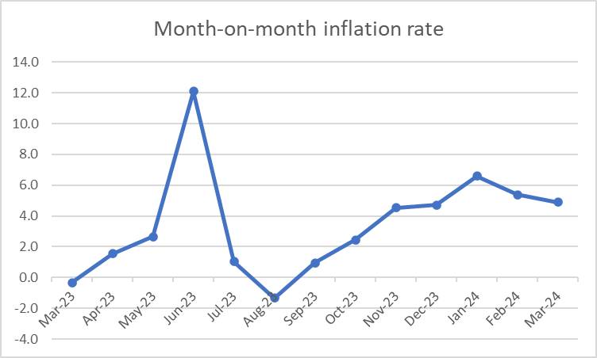
Source: ZimStat (2024)
6.5 Table 5 shows the main drivers of inflation in the month of March 2024.
Table 5: Inflation by Sector March 2024
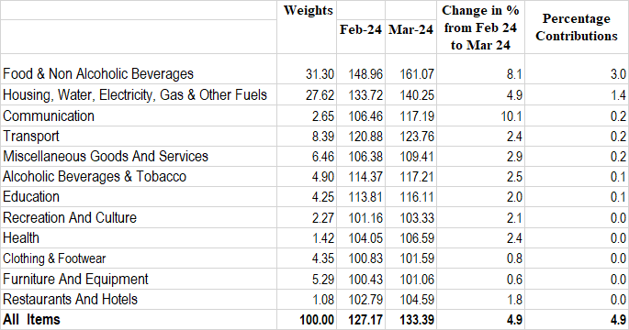
Source: ZimStat (2024)

Monetary Developments

7.1 Money Supply
7.1.1 At the time of compiling the report, the Reserve Bank had not published data on M3, thus analysis is based on data available up to January 2024. M3 reached ZW$18.870 trillion at the end of December 2023, up from ZW$14.271 trillion in June 2023 and further increased to ZW$29.248 trillion in January 2024. The expansion of ZW$3.176 trillion in transferable deposits accounted for the majority of the rise.

Figure 6: Broad Money Stock Movements
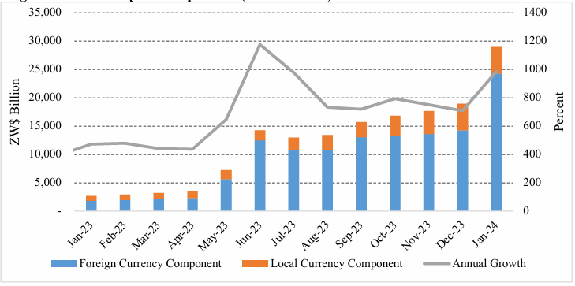
Source: RBZ (2024)
7.1.2 The money stock was composed of foreign currency deposits, accounting for 83.01%, local currency deposits constituting 16.94%, and local currency in circulation, 0.05%.

7.2 Interest Rates
7.2.1 During the period under review, the bank policy remained unchanged at 150% per annum.
7.2.2 Meanwhile, the ZWL$ minimum deposit interest rates on savings and time deposits were quoted at 30% and 50% per annum respectively while the minimum deposit interest rates on savings and time FCA deposits were at 1% and 2.5% per annum, respectively.

8.0 Stock Market Developments

8.1 Zimbabwe Stock Exchange
8.1.2 During the period under review, the Zimbabwe Stock Exchange recoded a bullish trend. All share index gained by 66.25% on MoM, while on YtD it gained by 62.96% and on YoY gained by 2165.50%. Similarly, the Top 10 index grew by 69.27%, 64.25% and 1643.26% on MoM, YtD and YoY (see Table 7).
8.1.3 The bullish sentiments that were exhibited on the local bourse during the month of March 2024, led to the addition of 70.91% of capitalization to end the month with ZW$67074270.88 million. On an YtD and YoY basis, market capitalization added 61.17% and 1971.43%, respectively as shown in Table 7.
Table 6: Zimbabwe Stock Exchange Movements
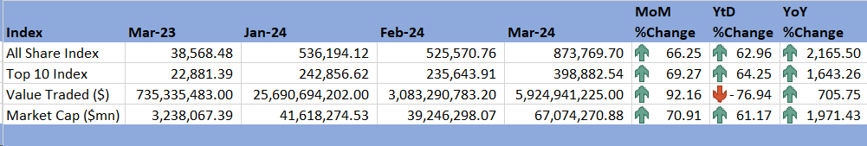
Source: ZSE (2024)

8.2 Victoria Falls Stock Exchange
8.2.1 During the month under review, the Victoria Falls Stock Exchange recorded a bullish trend. On MoM basis, the All Share Index gained by 2.52%, while valued traded gained by 15 419.54% and market capitalisation gained by 3.79% as shown in Table 8.
8.2.3 On a YoY basis, the All Share Index gained by 10.15% while the value traded gained by 225 745.12% and market capitalisation lost by 6.38%.
Table 7: Victoria Falls Stock Exchange Movements
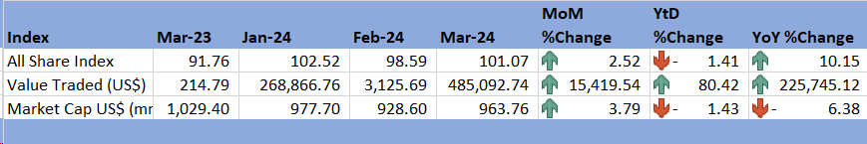
Source: VFEX (2024)

9.0 Recommendations
9.1 The following recommendations are being proposed:
9.1.1 The effects of El Nino induced drought have become severe than initially expected hence this calls for government intervention to reduce food insecurity by building grain reserves and the need to come up with winter farming programmes and irrigation farming systems to mitigate the effects of El Nino drought.
9.1.2 The continued devaluation of the Zimbabwean dollar and the widening of the parallel market premium highlights the necessity to strengthen the local currency in order to achieve macroeconomic stability by stimulating demand for the local currency and absorbing surplus liquidity thereby clearing exchange rates disparities. There is need for policy consistency and transparency to build trust and confidence in the general population of Zimbabwe.
9.1.3 The country continues to heavily rely on imports therefore, the Government should boost domestic production and promote exports to correct the trade imbalances. Value addition strategies are critical going forward. A widening trade balance tends to worsen the foreign currency situation and liquidity.

10.0 References
IMF. (2024). World Economic Outlook Update, January 2024. International Monetary Fund.
MOFEDIP. (2023). The 2024 National Budget Statement. Ministry of Finance, Economic Development and Investment Promotion.
RBZ. (2024). 2024 Monetary Policy Statement. Reserve Bank of Zimbabwe.
RBZ. (2024). Exchange Rates. Retrieved from Reserve Bank of Zimbabwe: https://www.rbz.co.zw/index.php/research/markets/exchange-rates
Trading Economics. (2024). Commodities. Retrieved from Trading Economics: https://tradingeconomics.com/commodities
VFEX. (2024). VFEX Main Dashboard . Retrieved from Victoria Falls Stock Exchange: https://www.vfex.exchange/
ZimStat. (2024). Inflation Rates. Retrieved from Zimbabwe National Statistical Agency: https://www.zimstat.co.zw/
ZSE. (2024). ZSE Main Dashboard. Retrieved from Zimbabwe Stock Exchange: https://www.zse.co.zw/

NECF Secretariat, 2024

